PHC 6701: Project 2

Wrangling Data with dplyr

Alvonee, Lea and Tanvir

2022-07-08

Table of Contents

# Introduction

For this project, we investigated the demographic transition that impacts public health worldwide by utilizing two different sources to obtain the data sets. This data can give insight into significant world events that emphasized public health disparities and how resources could have been allocated at the time.

The data set that consisted of the Continents/Regions was downloaded from Canvas, while the remaining five data sets were downloaded from the gapminder website <https://www.gapminder.org/data/> and included: infant mortality (rate per 1000 births), life expectancy (years), babies per woman (total fertility), the total population, and the total GDP (PPP$, inflation-adjusted).

The variables within the gapminder data included different characteristics of the countries of different continents, their income, population size, life expectancy as well as infant mortality and fertility rates between the years of 1799 and 2099.

Before the analysis was performed, it is important to note that we calculated the gdpPerCap and then converted the population size into millions. We also performed a sanity check with the original dslabs gapminder data. The purpose of this was to randomly cross-check our data and ensure that it is consistent and functional.

## The Bubble Chart

### The Bubble Chart–Single Year

Using the GapMinder website, we attemtped to replicate the bubble chart for the year 2001.

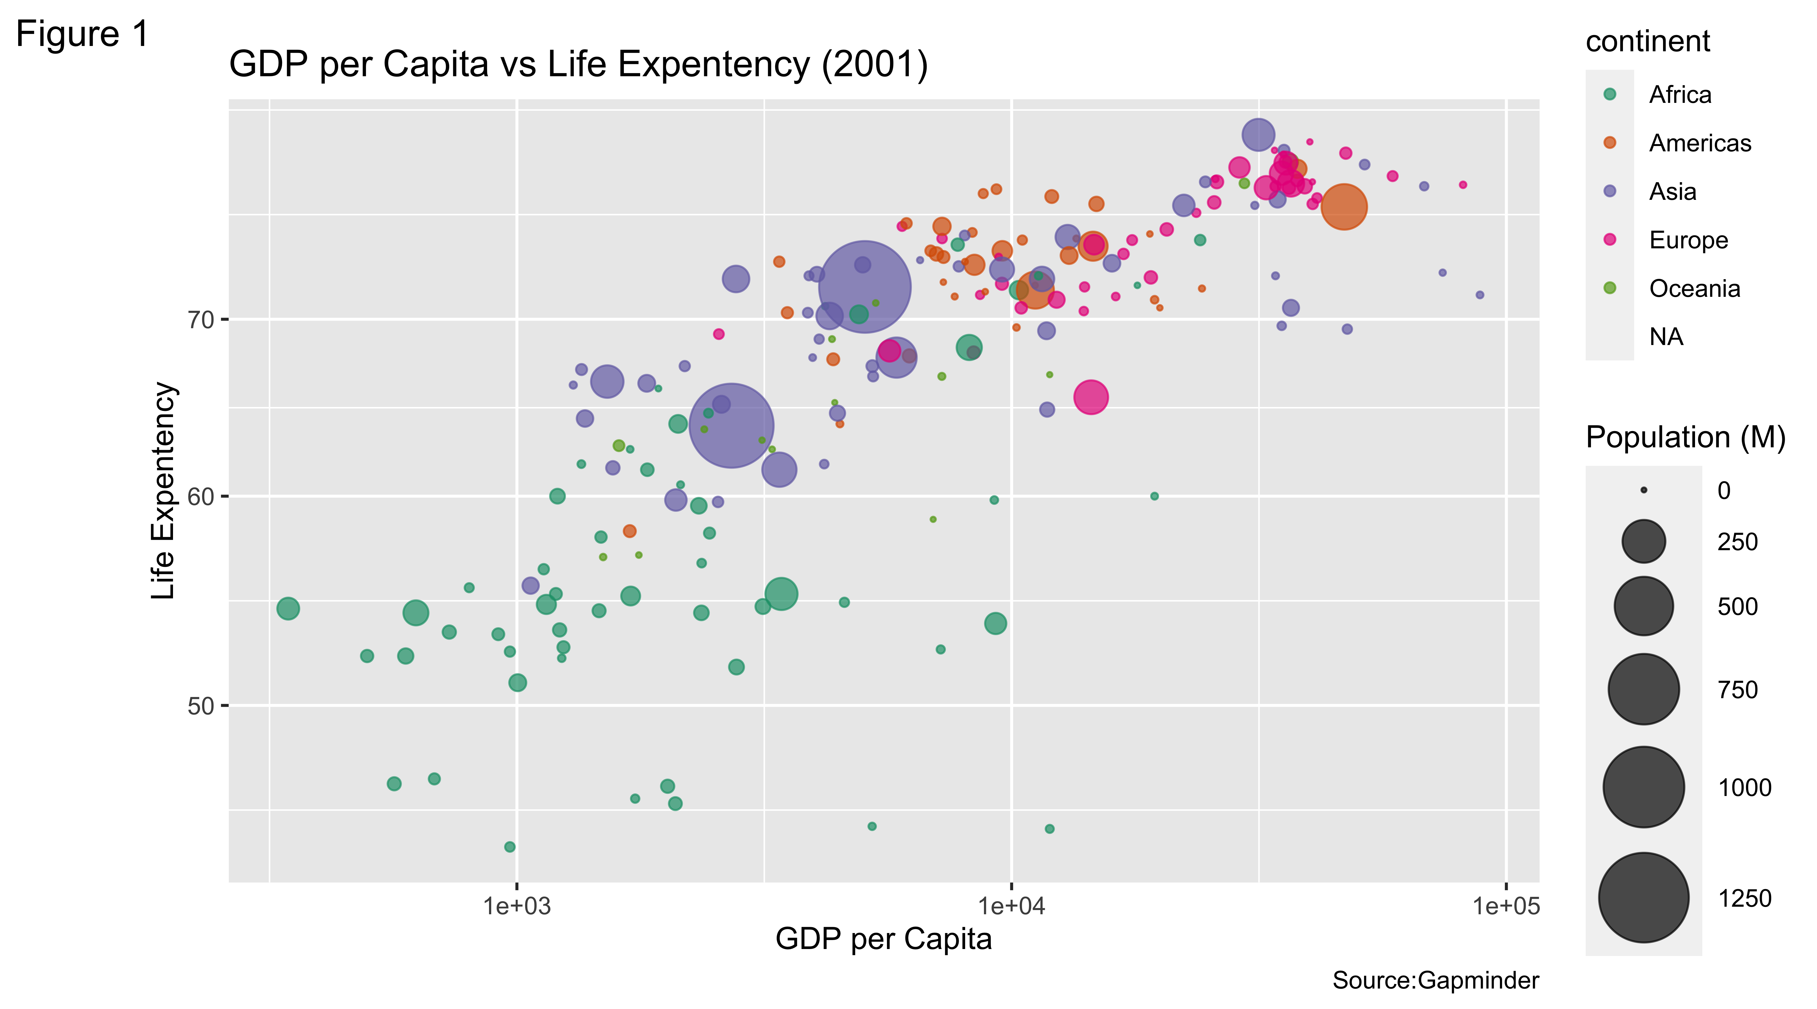

Figure 1 demonstrates the gapminder data that shows the GDP per capita (income) on the X-axis vs. life expectancy on the Y-axis in the year 2001. On the graph, the colors represent the continents while the size of the population is represented by the size of the dots. For example as shown by the legend, teal colored dots represent African countries while orange dots represent countries from the Americas. The size of the dot reveals the size of the population.

It was hypothesized that Western countries would have a higher life expectancy, and a higher income than other countries, whereas Asian countries would have the larger population size. Moreover, it is hypothesized that countries with a higher GDP per Capita (income) would show a longer life expectancy outcome of the population. This is because a better quality of life and health status is reflective of the socioeconomic conditions of the individual. Once the statistics per country were plotted, it was noted that Asia had the largest population. Europe and the Americas had a much higher life expectancy than that of Africa, as expected.

This indicates that disparities in African countries still persist and there need to be adequate resources supplied to increase economic growth, decrease mortality rates and thus increasing life expectancy.

### The Bubble Chart over Time

We chose the following years (1960, 1980, 1990, and 2011) in the modern era to evaluate the life expectancy based on income.

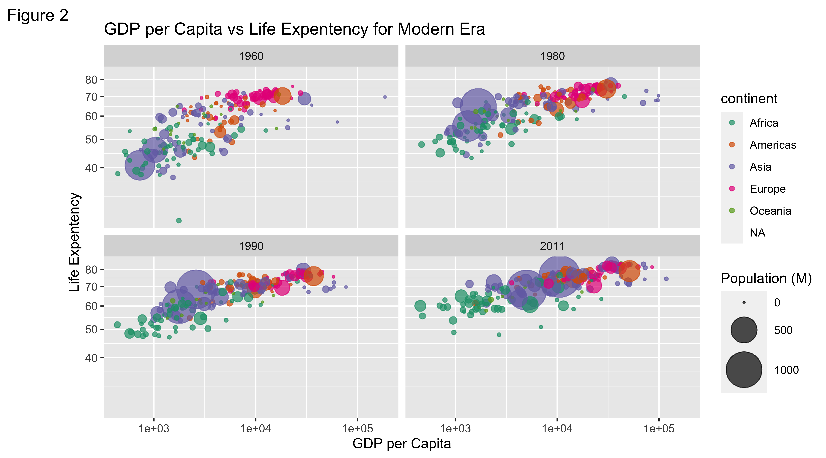

Figure 2 also plots the GDP per Capita (income) on the x-axis vs. life expectancy on the y-axis. However, this figure takes into consideration the modern era and compares worldwide data across 4 different years: 1960, 1980, 1990 and 2011.

Just like figure 1, the colors in figure 2 represent the continents while the size of the population is represented by the size of the dots. For example as shown by the legend, teal colored dots represent African countries while orange dots represent countries from the Americas. The size of the dot reveals the size of the population.

It is important to consider key events that occurred during those decades which could reflect the major changes seen in the graphs.

* 1960 had some major events like the Cold War as well as the Vietnam War.
* 1980’s event consisted of a major recession and an increase in unemployment worldwide.
* 1990 was a positive year globally.
* 2011 a continuation in the recovery of the global economy.

For this reason, we hypothesize that over the years, there was an increase in the GDP per capita as the global economy improved with a decrease in world wars and instabilities. One important finding is that the life expectancy of Asian countries increased since the 1960s while that of African countries had a slower trajectory.

This demonstrates that when there is more political and economic instability worldwide, there will be a lack of resources, more disparities and poorer life expectancy.

## The Growth Chart

### GDP per Capita

We plotted the GDP er capita (income) for 5 countries: China, Russia, the US, India, and Bangladesh between 1960 and 2016.

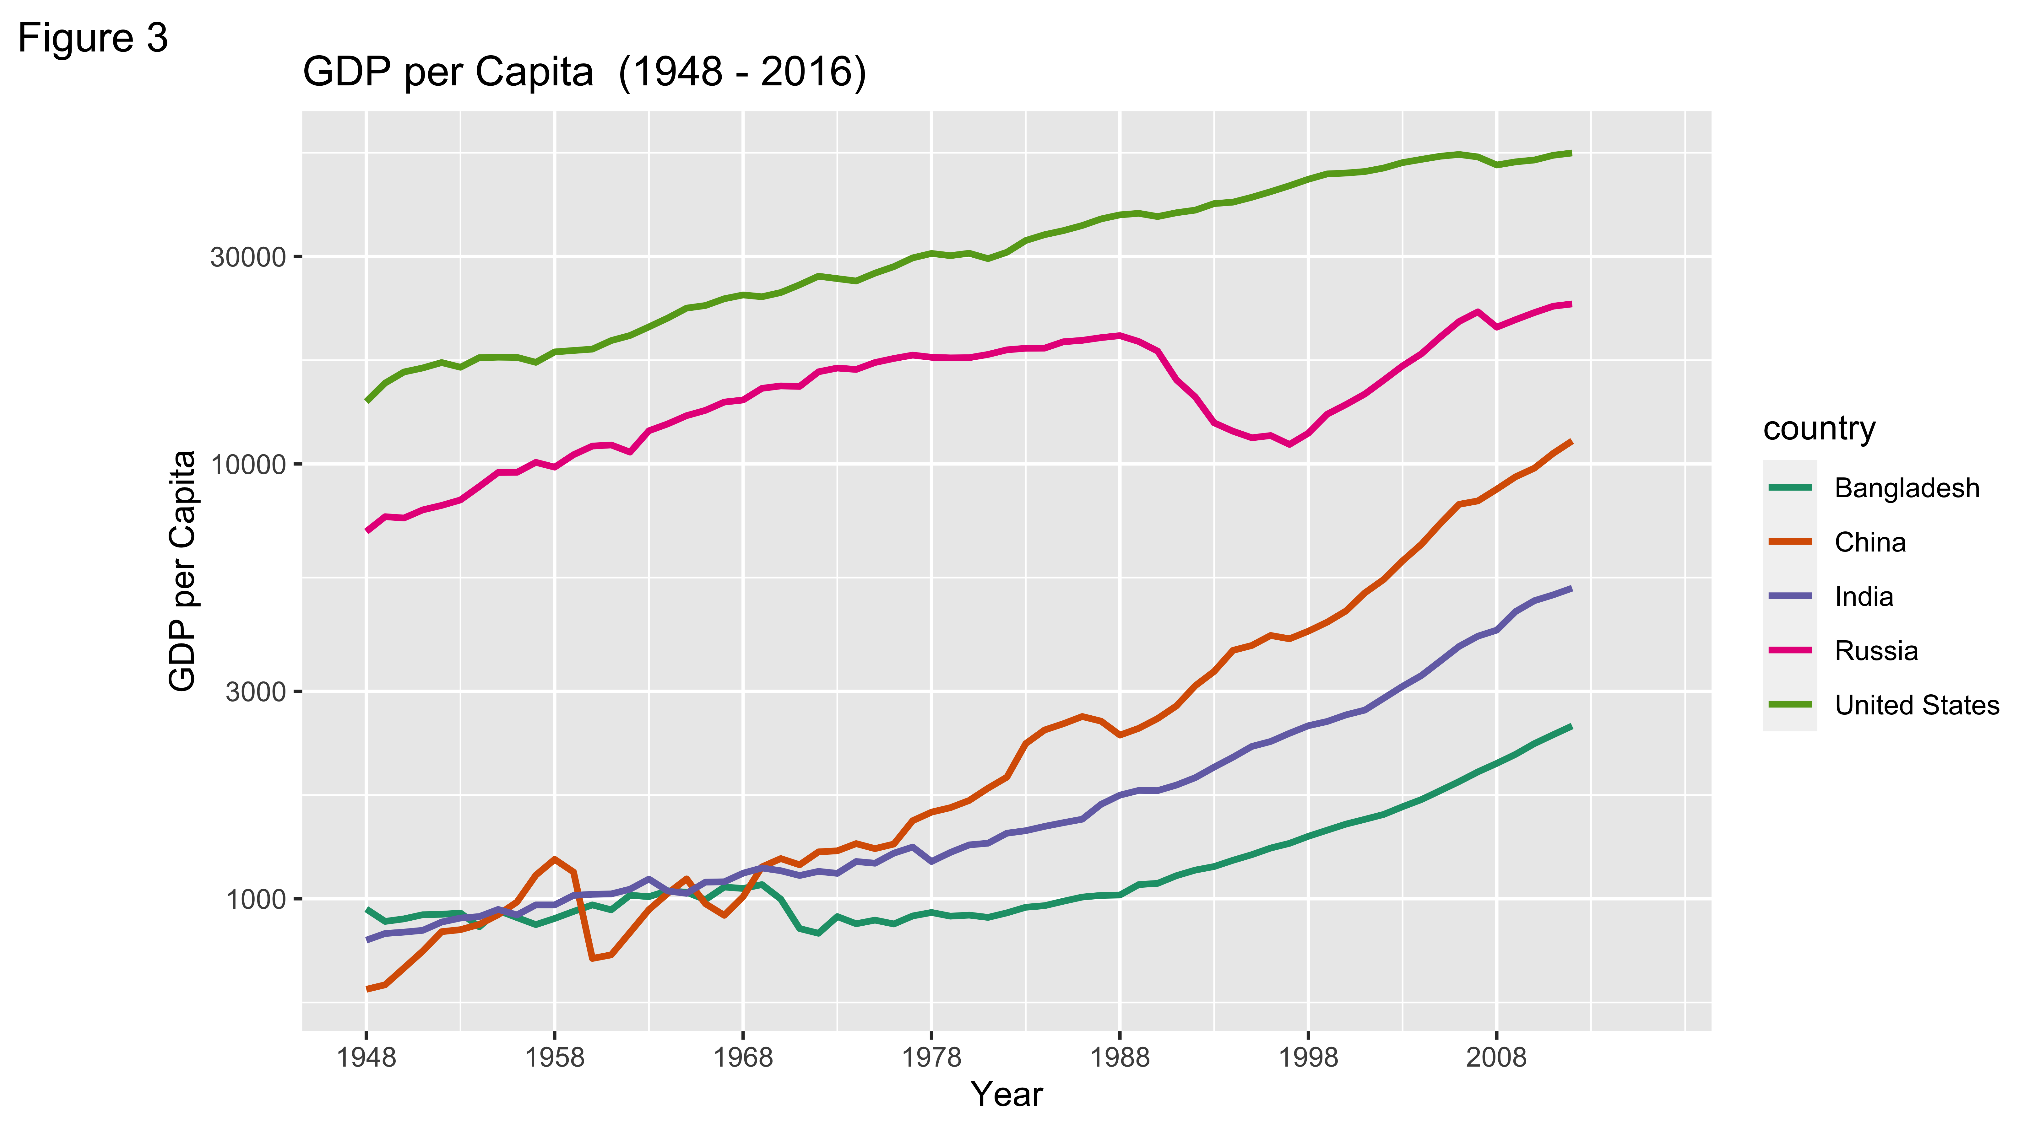

Figure 3 illustrates the GDP per capita (income) which falls on the y-axis, between the years of 1960 to 2011 (x-axis) for 5 different countries: Bangladesh (seafoam green), China (orange), India (purple), Russia (pink), and the United States (dark green).

It was hypothesized that over time, the GDP per capita would increase for all 5 countries since there is economic growth, urbanization, technology, more education and better access to resources. Once the data was plotted, it was demonstrated that there was indeed an overall growth curve for all 5 countries. However, it is important to note that for Russia, the curve does not begin until the late 80s-early 90s followed by a dip in income between the years of 1990 and 2000. This could have been attributed to the fallout of the Soviet Union making the establishment of Russia difficult and burdensome on the economy. Additionally, the United States’ GDP per capita since the 60s had been well over $10,000 and it could have been due to its political and economical layout emphasizing a capitalistic country compared to that of Russia and China.

On the other hand, 1971 was the year that Bangladesh gained its independence following the Liberation War between India and Pakistan. Then, towards the end of 1973 the Bengali people had endured extreme famine, one of the worst recorded famines in the 20th century, which led to an extremely high mortality rate of approximately 1.5 million people. Since then, this country is one of the many that has been very slowly developing which is demonstrated by their gradually increasing trajectories of GDP per Capita. China’s infant mortality rate trend is a bit interesting since overall it had a decrease rate expect for a slight increase in the 1950s. Chairman Mao Zedong’s ‘Great Leap Forward’ failed to industrialize the country which led to a famine, thus increased the infant mortality rates. <https://www.macrotrends.net/countries/BGD/bangladesh/gdp-per-capita> <https://www.statista.com/statistics/1042745/china-all-time-infant-mortality-rate/>

### Infant Mortality

We plotted infant mortality for the same 5 countries: China, Russia, the US, India, and Bangladesh between the years 1960 and 2016.

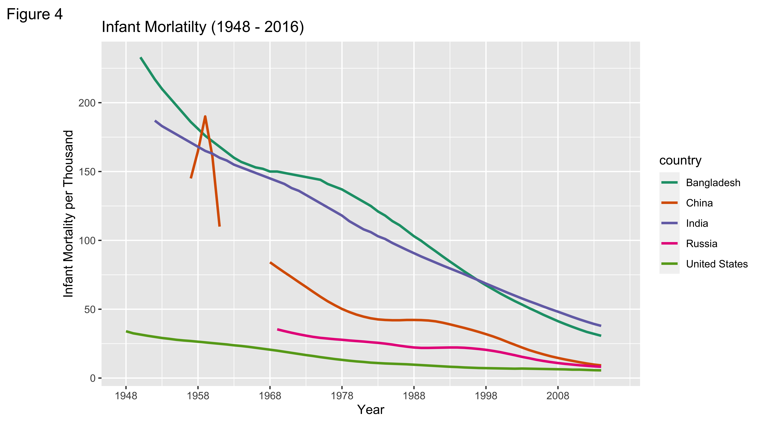

Figure 4 plots infant mortality rates per 1,000 on the y-axis over the years beginning 1960 up until 2011, labeled on the x-axis. Just like figure 3, there are 5 different countries: Bangladesh (seafoam green), China (orange), India (purple), Russia (pink), and the United States (dark green).

It was hypothesized that those who have the lowest GDP per capita will have the highest infant mortality rates. The results reveal that this hypothesis was confirmed. Additionally, it is important to note that we observed a major decrease in infant mortality rates due to the increase in the GDP per capita (income) over the years in all 5 countries.

One noteworthy trend is that of China (orange) which had a severe dip in infant mortality rates between 1960 and 1970. It is noted that during this time, China had implemented a “Patriotic Health Campaign” under Mao which helped establish a wide range of public health activities that increased health promotion and helped to decrease disparities and health burdens including infant mortality rates as they transitioned into a country with more socialist beliefs. <https://www.ncbi.nlm.nih.gov/pmc/articles/PMC4331212/>

This is a really significant improvement and has a lot of implications for the future of public health in order to help decrease infant mortality rates in other countries that are still developing.

## Rank Charts

### Population Rank by GDP/Capita

We ranked and plotted the countries by their population sizes for the year 2011, and filled the bars by the GDP per capita of the top 15 countries by their population size.

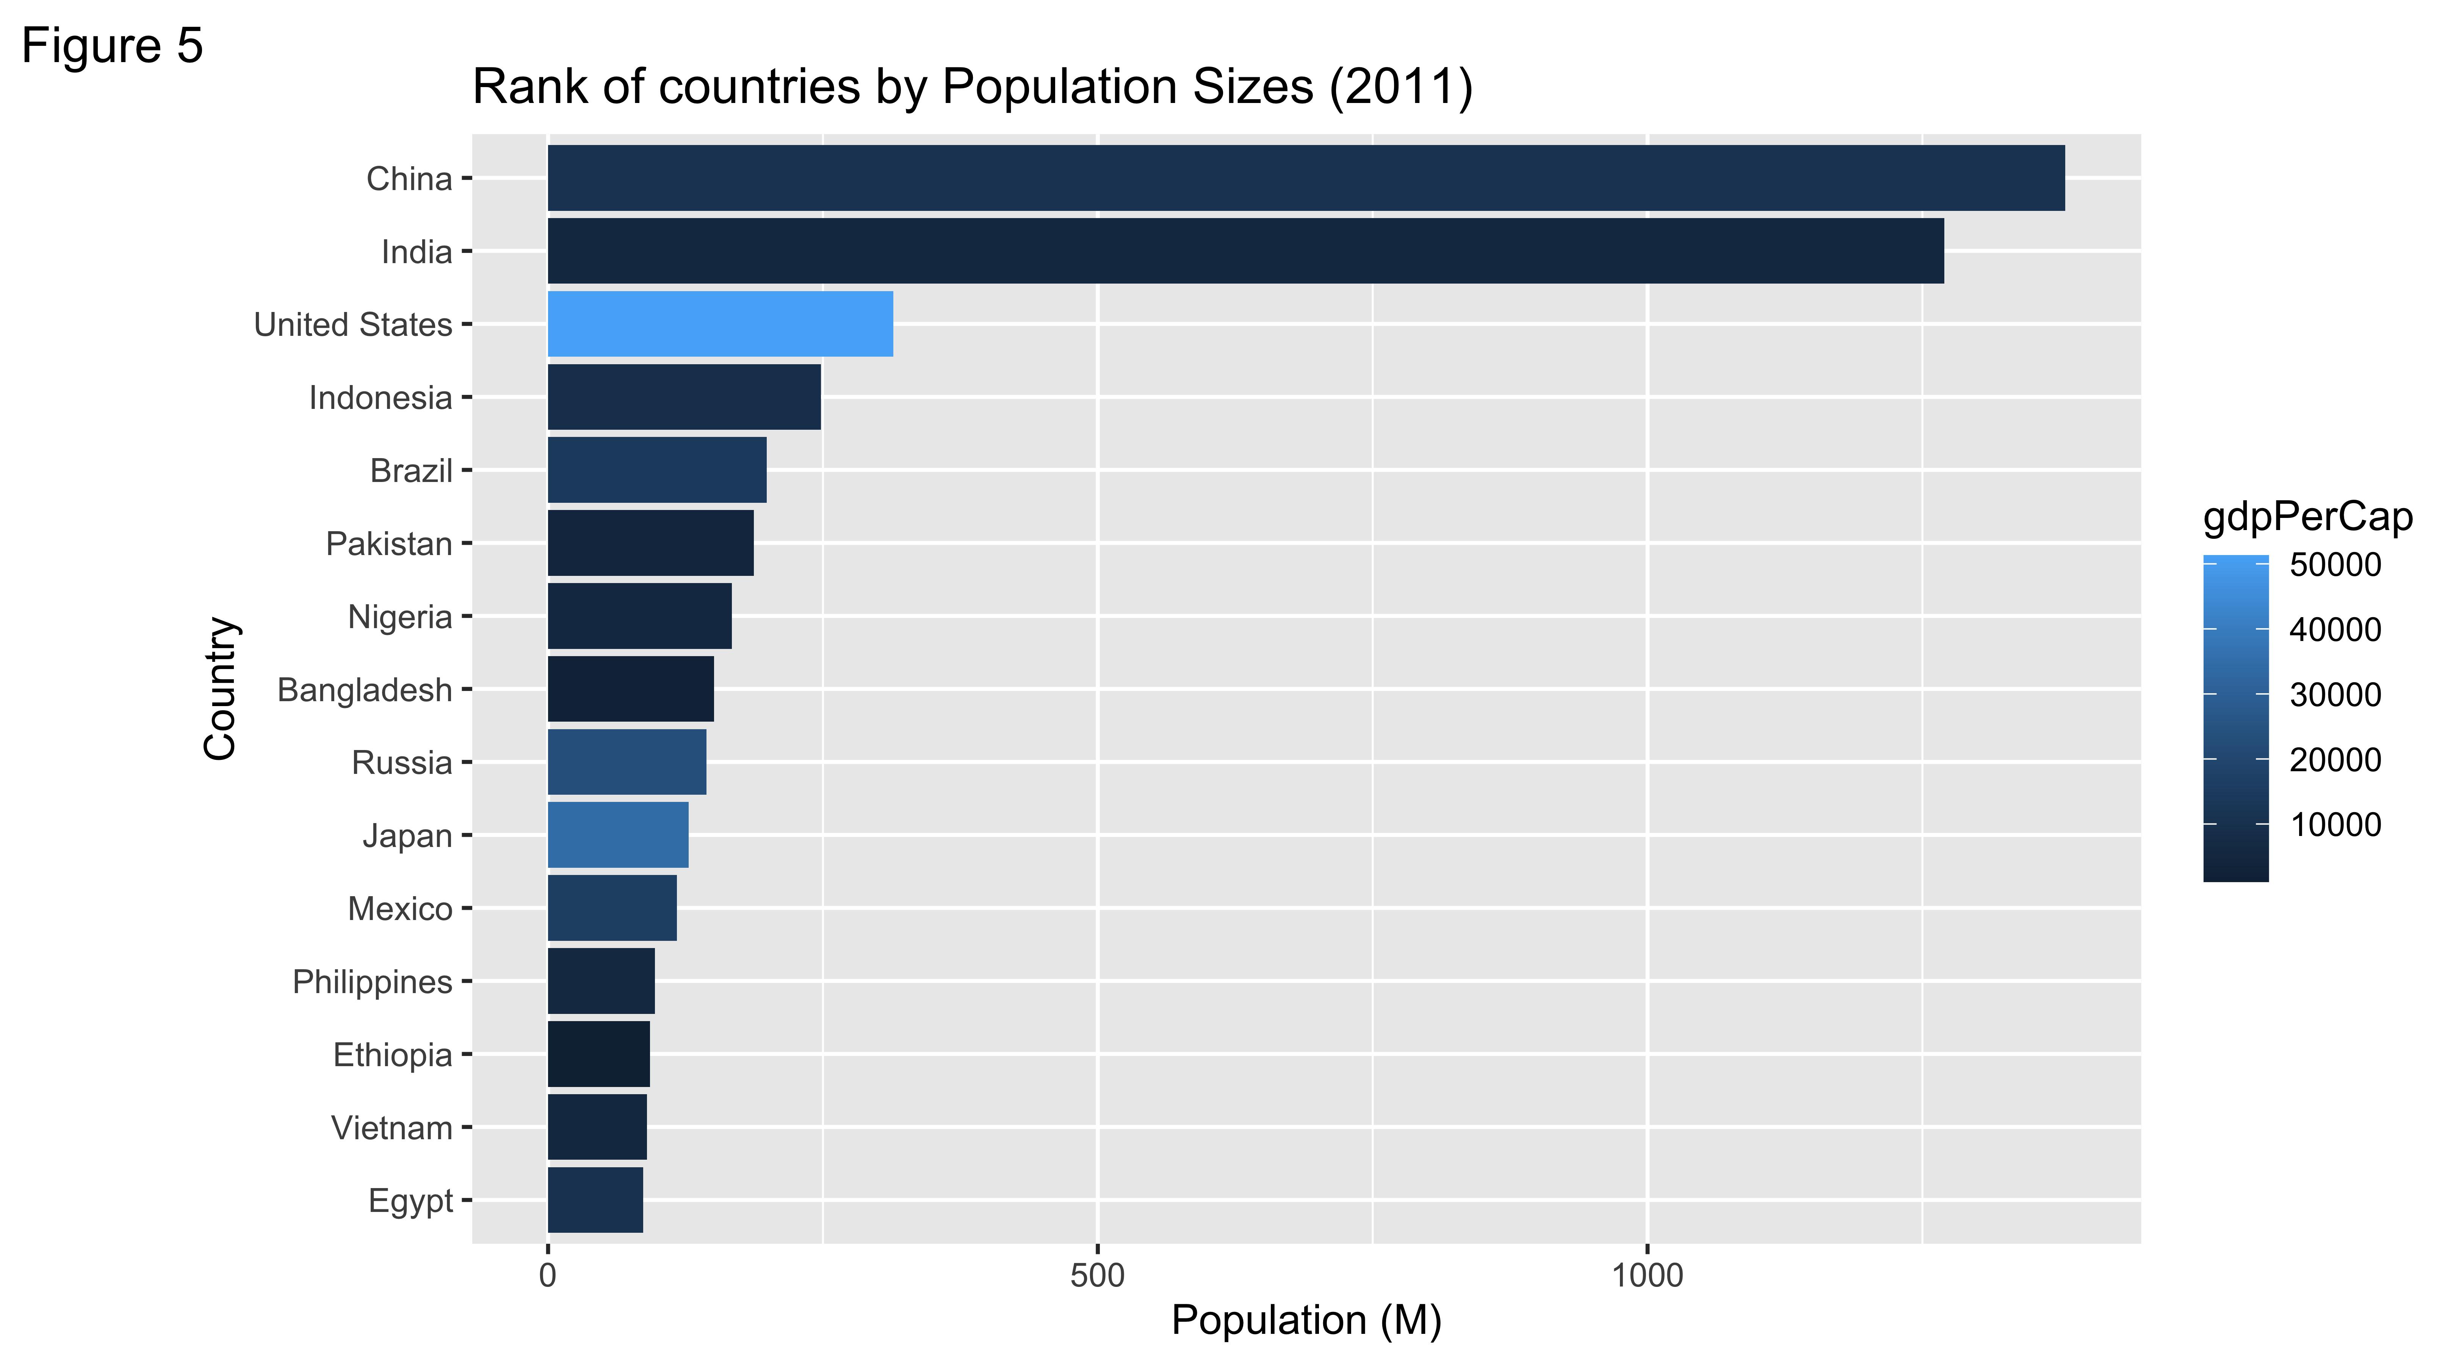

Figure 5 shows out the top 15 countries (y-axis) and their population size (x-axis) while the color reflected the GDP per capita (income). The darker blue color is a representation of the countries with lower GDP per capita and the lighter blue color reflects the coutnries with the highesr GDP per capita.

It is hypothesized that the countries with a larger population will have a smaller GDP per capita. The reason behind this hypothesis is that since the GDP is divided by population size this means that a larger population would be more difficult to sustain economically.

The graph has actually confirmed our hypothesis with the exception of two countries: the U.S. and Japan. Even though the U.S. has a similar population to Indonesia and Brazil, or Japan having a similar population to Mexico and Russia, both countries (U.S. and Japan) have a much higher GDP and this can be attributed to the developed infrastructure and technology of the two countries compared to the rest.

This is important because it indicates that when the GDP per capita is higher per country, it is reflected in better health outcomes of the population and an overall prosperity.

### Infant Mortality by Population

We ranked and plotted the countries by their infant mortality rates for the year 2011, and filled the bars by the population of the top 15 countries with the highest infant mortality rates.

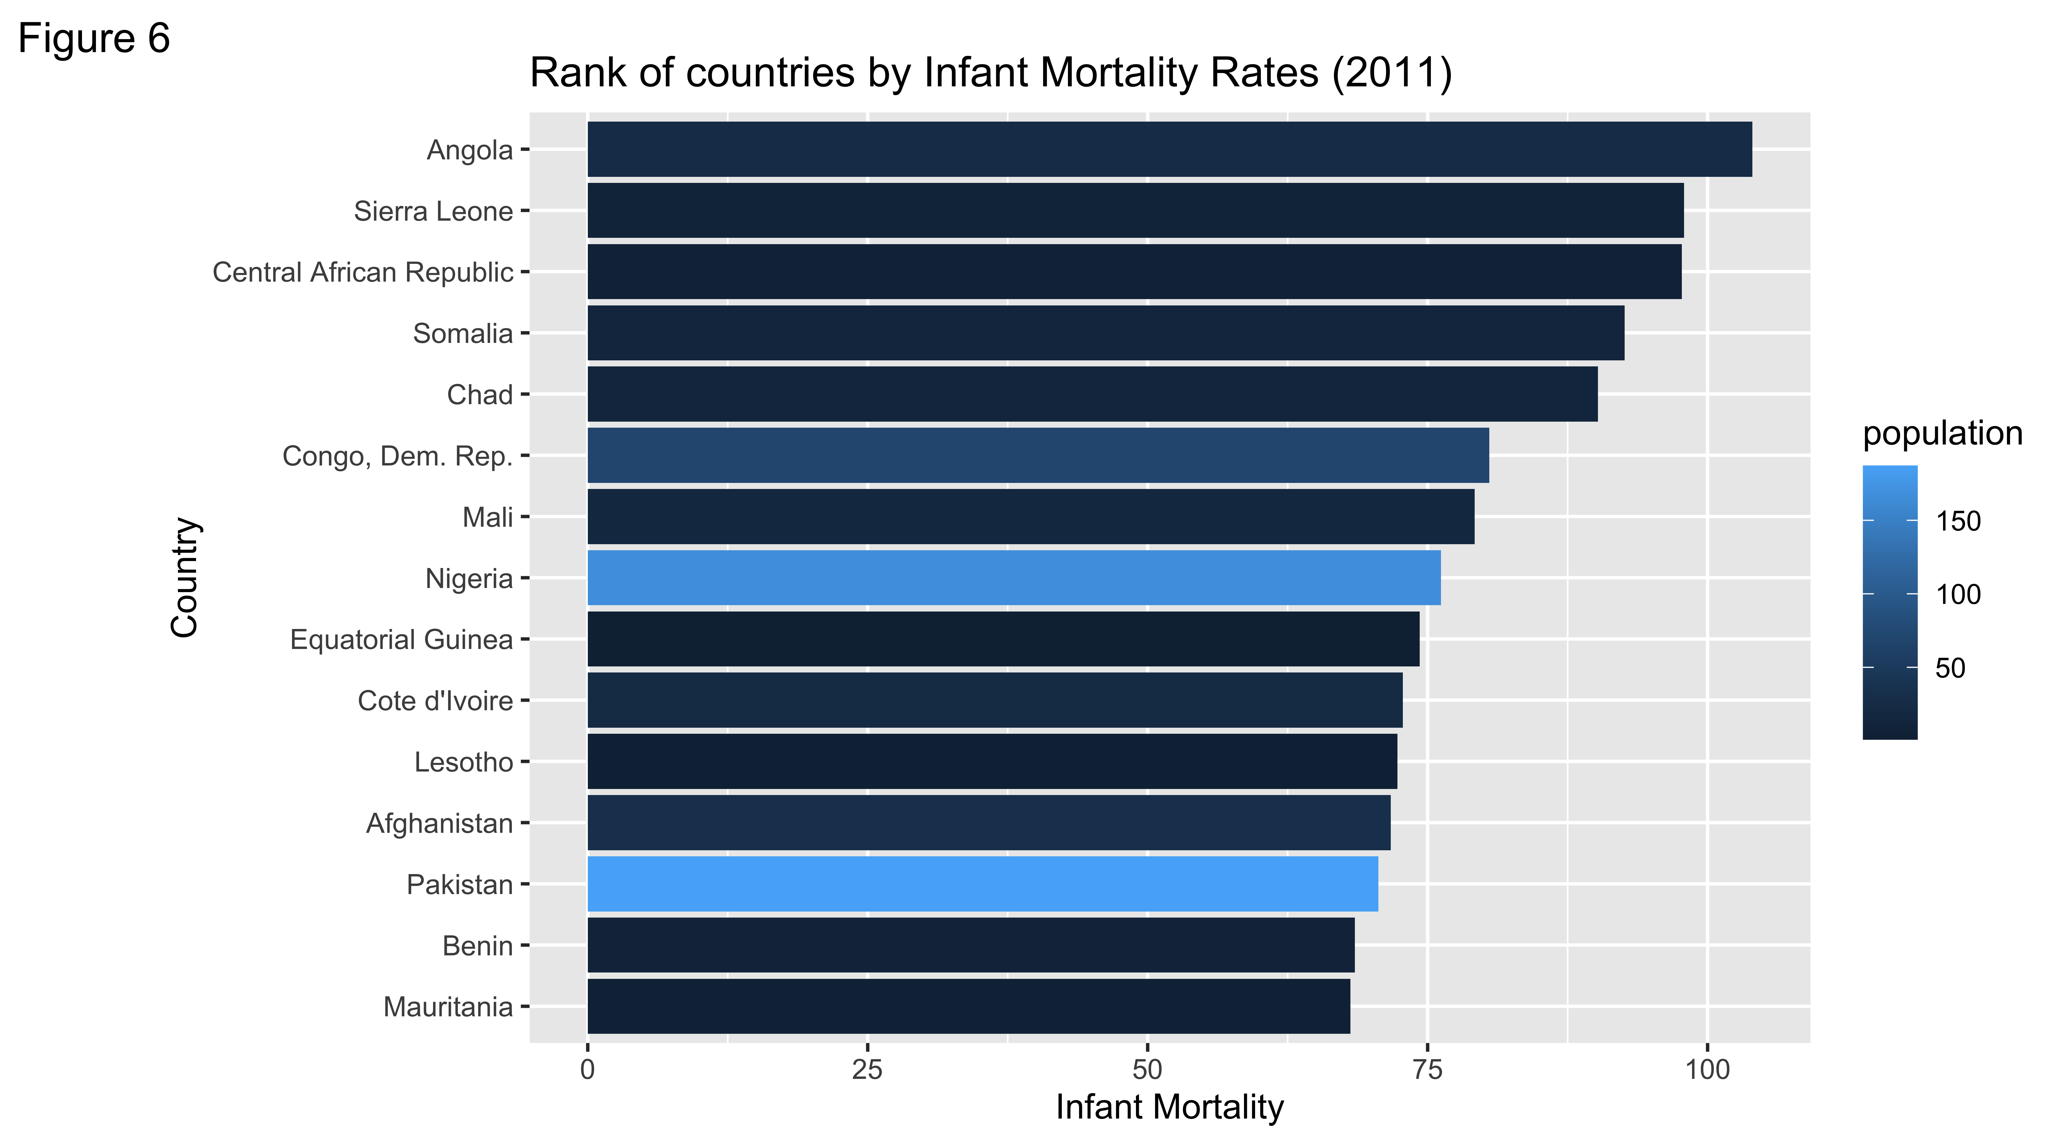

In the figure above, the x-axis labels infant mortality rate per 1000 and on the y-axis it labels the top 15 countries with highest infant mortality rates. The dark blue indicates countries with smaller populations while lighter blue countries are those that reflect larger populations.

It is hypothesized that those smaller countries will have higher infant mortality rates due to lack of resources, infrastructure, higher poverty rates, etc.

The general trend that is observed shows that smaller countries have higher infant mortality rates with the exception of Nigeria and Pakistan. Pakistan actually had a population of 183.3 million individuals in 2011, whereas Nigeria had a population of 162.8 million individuals. In 2011, the election that took place in Nigeria actually led to economic and political conflicts within the people which led to some famines and lack of resources thus the higher observed infant mortality rates. Whereas in Pakistan, their economy was not stable due to the political instability and civil unrest. In Pakistan, infant mortality is more sensitive to economic fluctuations, especially during negative shocks to GDP. In Nigeria, inadequate health care services remains a front line problem in addressing infant mortality. In addition to this, the risk of childhood mortality are lowest among mothers with formal education, mothers living in urban areas, and mothers who were older. <https://bmcpublichealth.biomedcentral.com/articles/10.1186/s12889-017-4420-7>

The results emphasize the need for more public health interventions such as better resources for pregnant mothers and prenatal care that can help decrease the rates of malnutrition in infants. Additionally, if better education is implemented regarding sex ed and condom usage could prevent economic family burden through better family planning.

## Additional Graphs

### Bubble Chart for Differnt Years

For year 1860, 1910, 1960, and 2010 we evaluated the life expectancy based on income and similar trends were found in figure 7 as in figure 2.

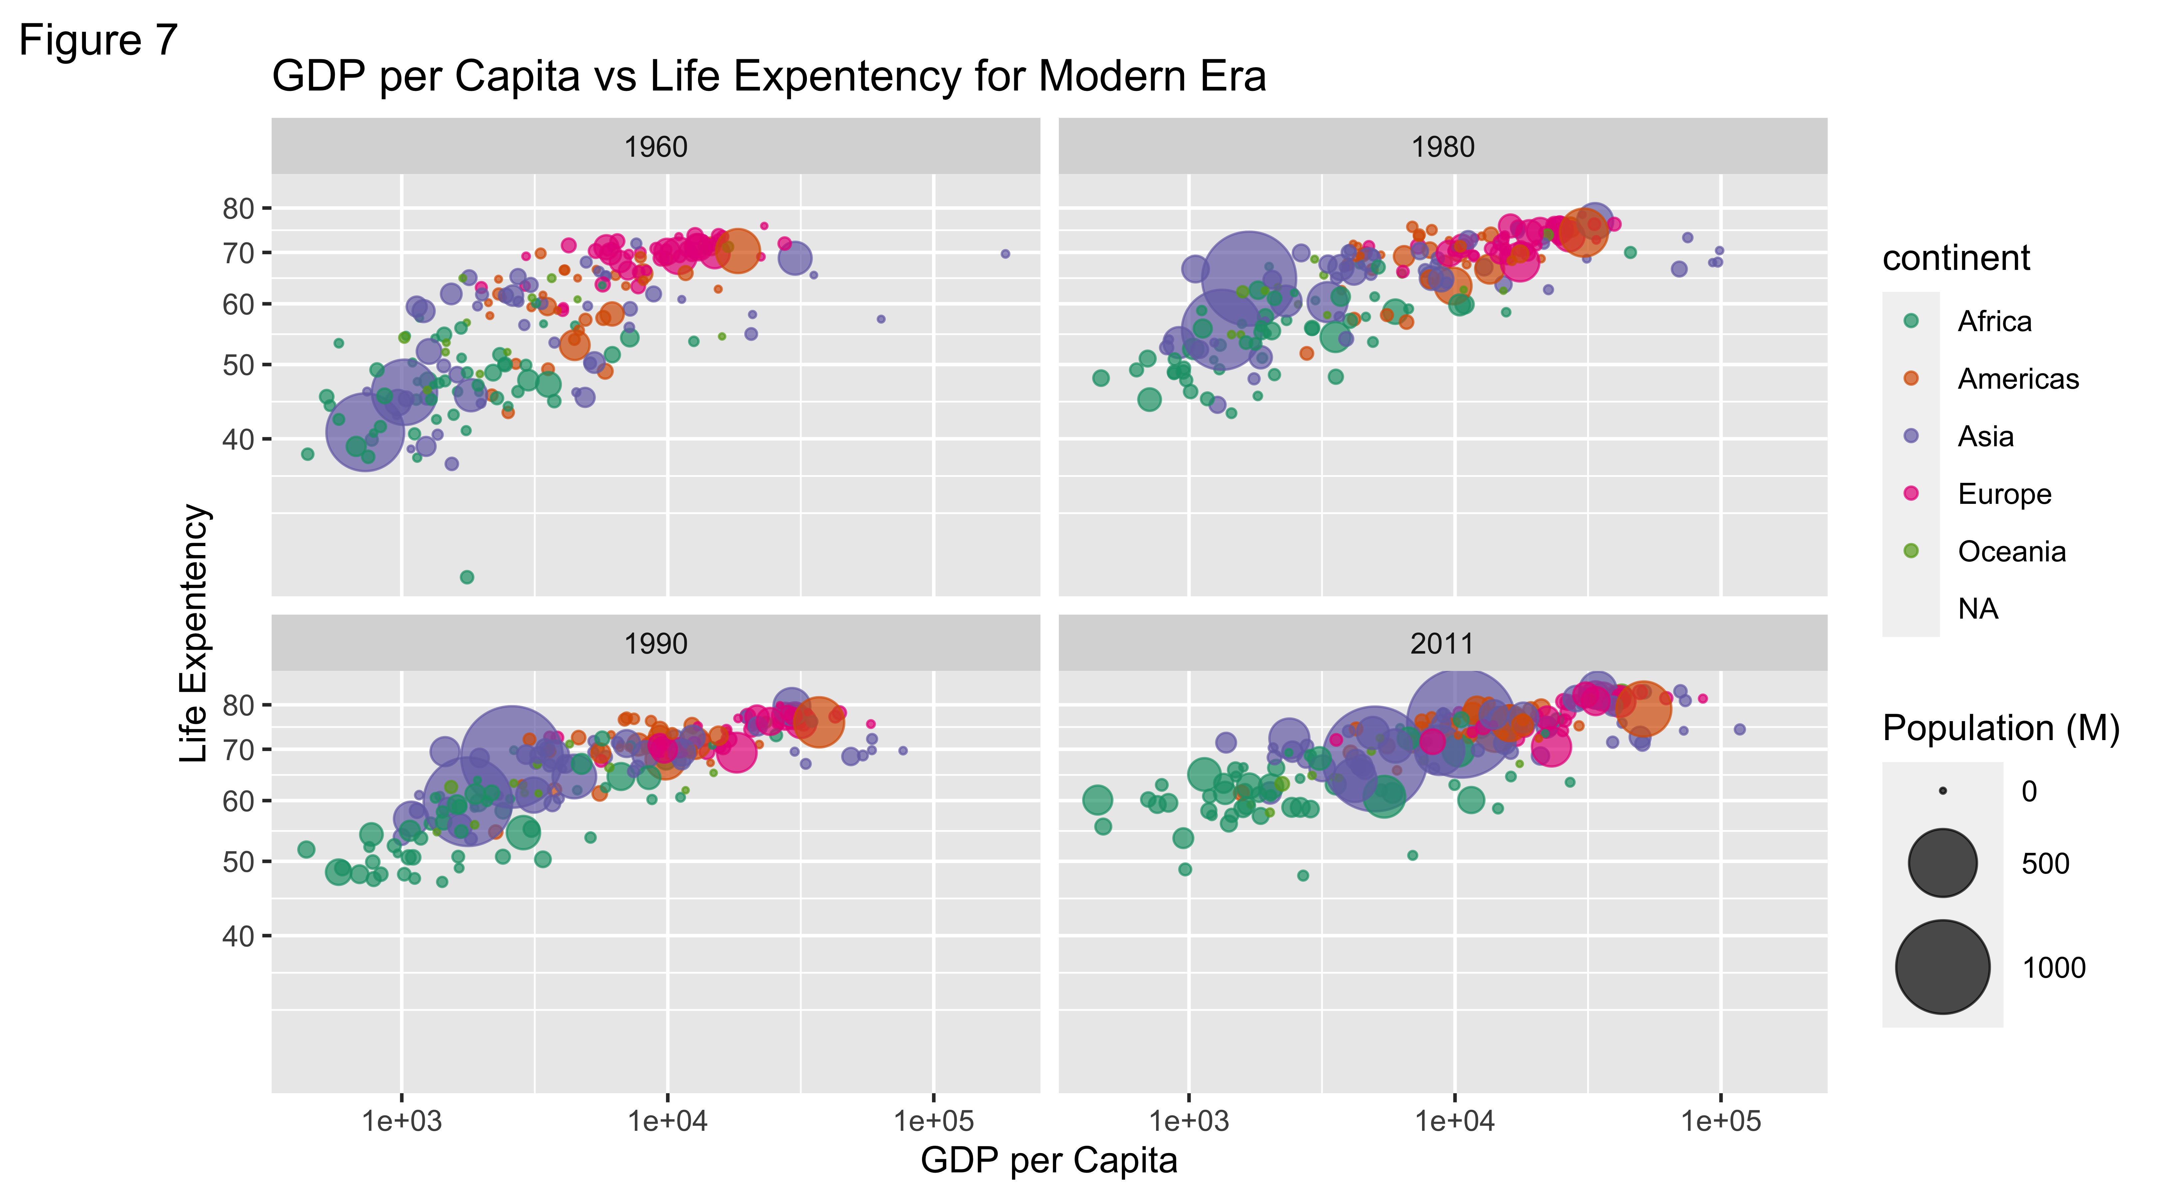

### Infant Mortality by gdpPerCap

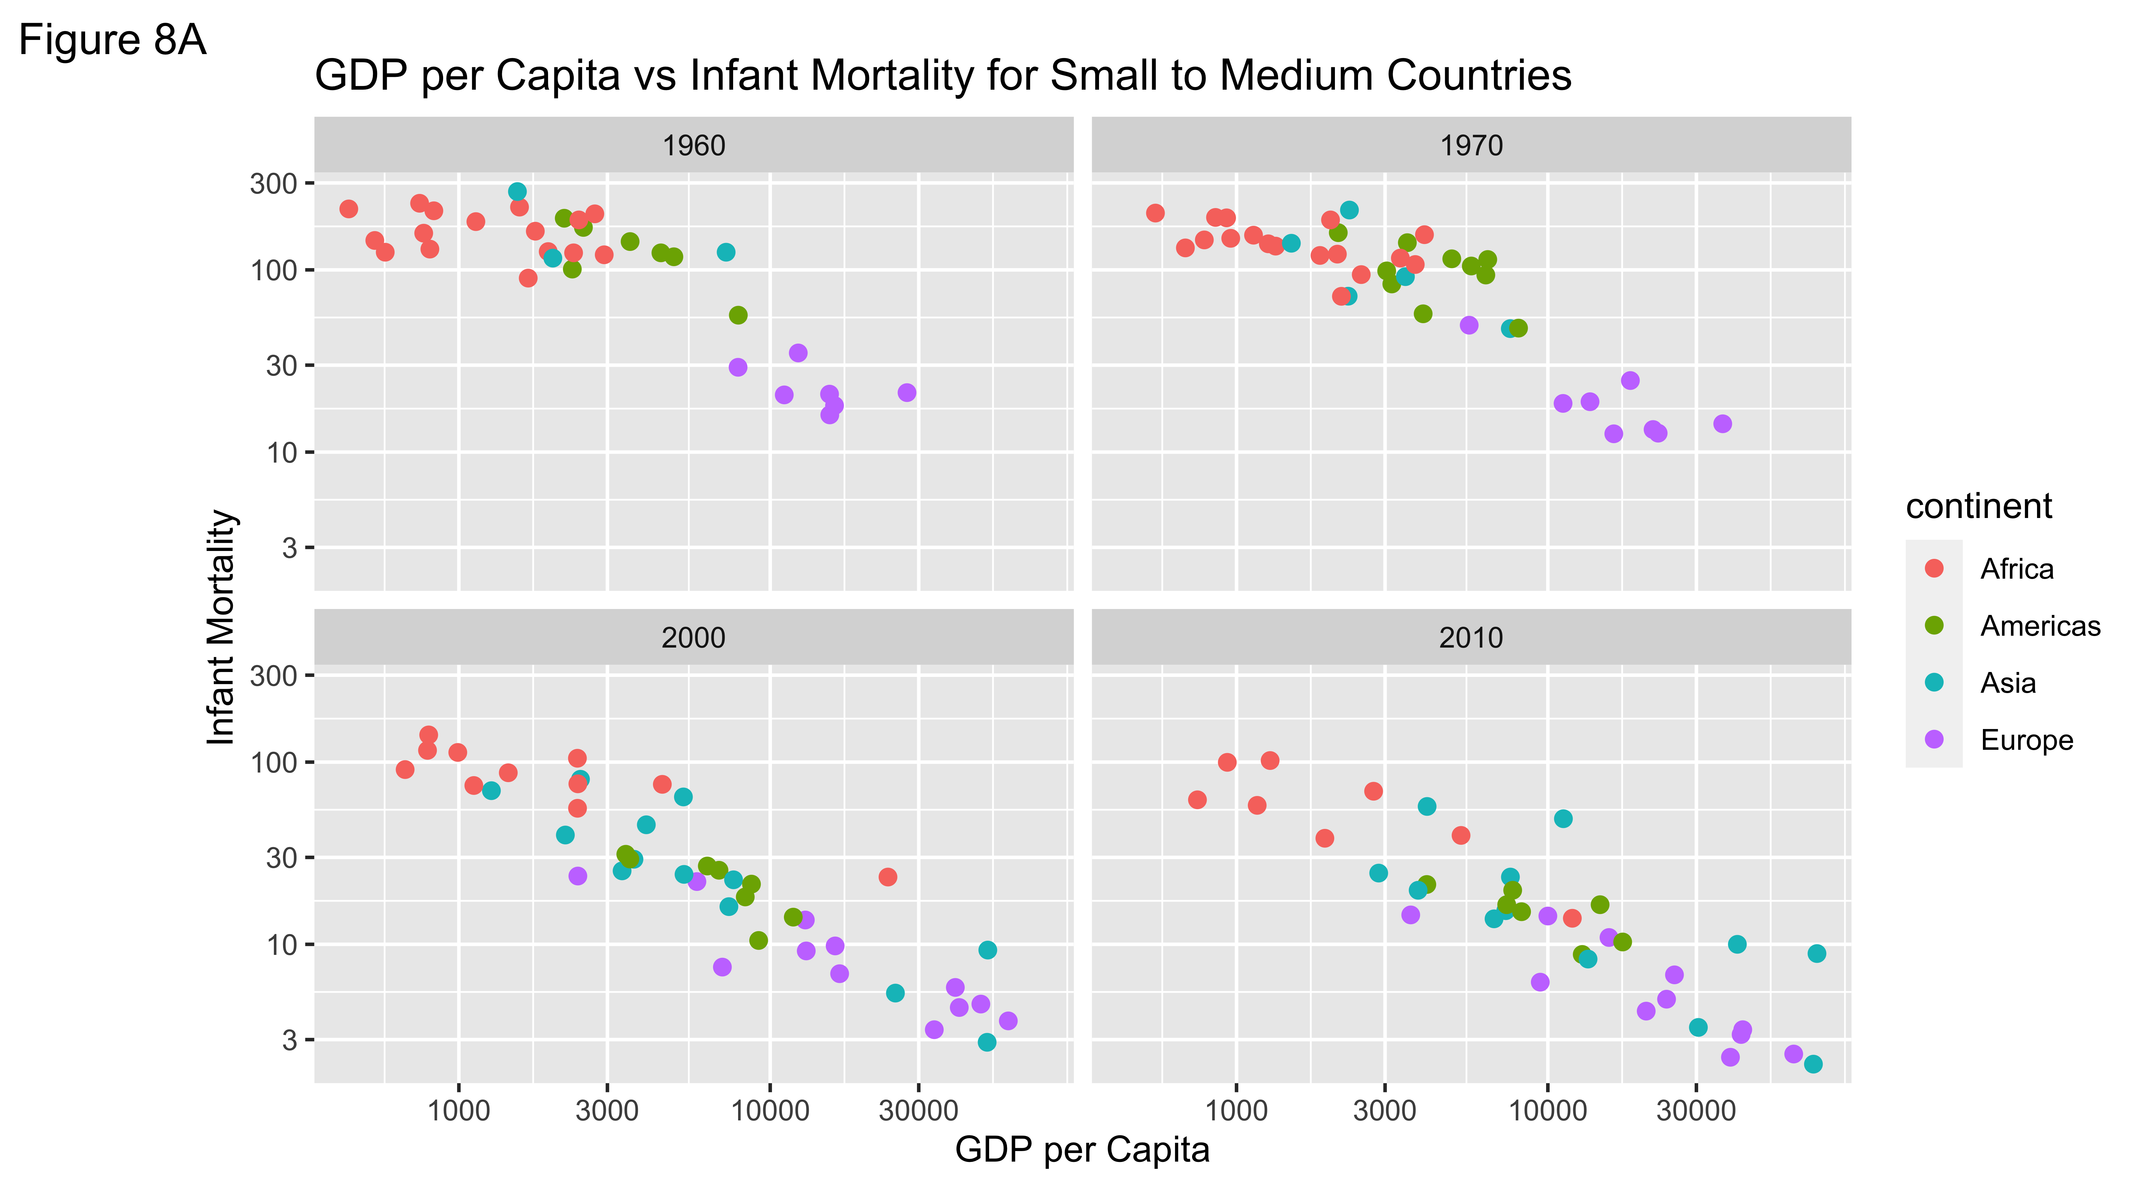

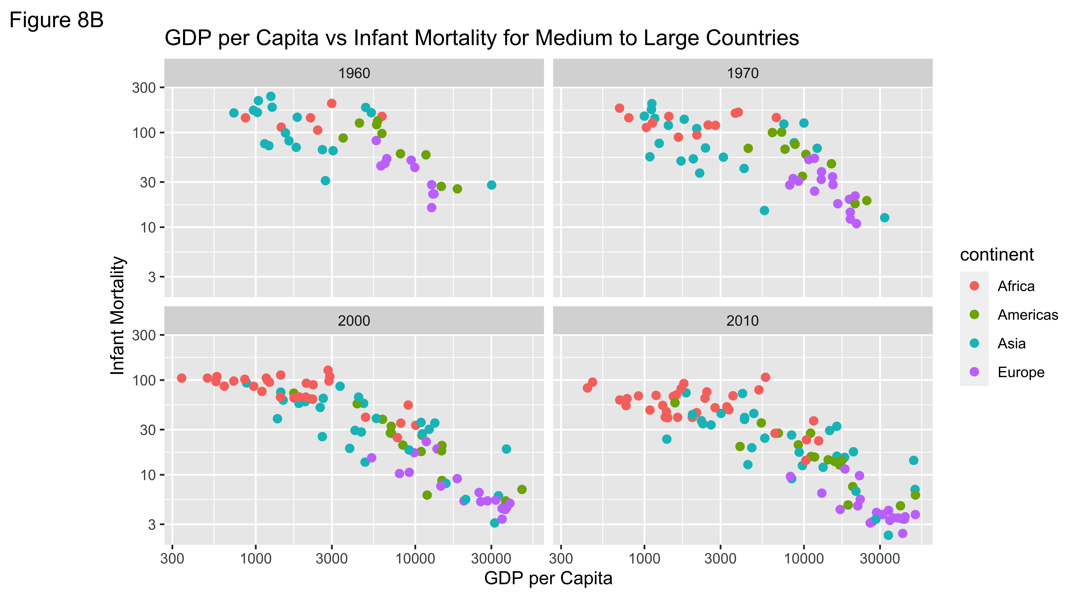

In figure 8, we created a visualization chart to test the running hypothesis that countries with higher infant mortality would have lower GDP per Capita. We purposely selected 4 continents, Africa (coral), The Americas (green), Asia (teal), and Europe (periwinkle) to cross-match and compare this trend. We then divided the countries into small (2.3 million) to medium (7.6 million) population sized countries (figure 8A) and medium to large sized countries (figure 8B) varying above 7.6 million people in size. We excluded Oceania as this continent has only two large population sized countries (New Zealand and Australia), which could have potentially skewed the relationship of this trend. We then divided each figure into four separate years (1960, 1970, 2000 and 2010).On the X-axis, we plotted the GDP per Capita and on the Y-axis we plotted infant mortality. It is important to note that the values are plotted on a log10 scale.

As stated in figure 6, we had expected that countries with higher GDP per capita would have lower infant mortality rates. This is due to the importance of socioeconomic conditions, like household income, education status and environment, which are reflective of health status, like that of birth weight and mortality rates. <https://www-ncbi-nlm-nih-gov.ezproxy.fiu.edu/pmc/articles/PMC3791093/> <https://genus.springeropen.com/articles/10.1186/s41118-019-0071-0>.

As we can see from both figures, there is a clear inverse relationship between GDP per Capita and infant mortality rate. However, it is interesting to look at some outliers like that of Asia. In 1960 and in 1970, Japan was the only country to have an extremely low infant mortality rate and a really high GDP per Capita. In the 60s and 70s, Japan was booming technologically and industrially. Whereas in 2000 and in 2010, Saudi Arabia was the outlier of all the Asian countries due to its wealth from the Oil industry which led to an increase in economic standard with a very good livelihood satisfaction.

Overall, there is an inverse relationship between GDP per Capita and infant mortality rates across all years and across all population sizes. Additionally, there is an overall increase in GDP per Capita and a decrease in infant mortality rates across all countries.

# Conclusion

After seeing the graphs of the countries in the different continents over time, some key statistics and conclusions that were observed are as follows:

* Countries with a higher GDP per capita (income), showed a longer life expectancy outcome of the population.
* Overall, lower life expectancies were mostly observed in lesser developed countries like that of Africa.
* Overtime, the GDP per capita was increasing for all the countries with an improvement in life expectancy.
* It was observed in figure 6 and confirmed in figure 8 that countries with a lower GDP rate had higher infant mortality rates. Additionally, Europe was the leading continent in low infant mortality rates and higher GDP per Capita across all years and all population sizes.
* It is hard to implement public health interventions in countries with larger populations and smaller GDP per capita due to the lack of resources.